HUDSON VALLEY DRAFT HORSE ASSOCIATION THE MID-HUDSON DRIVING ASSOCIATION ULSTER COUNTY HORSE COUNCIL

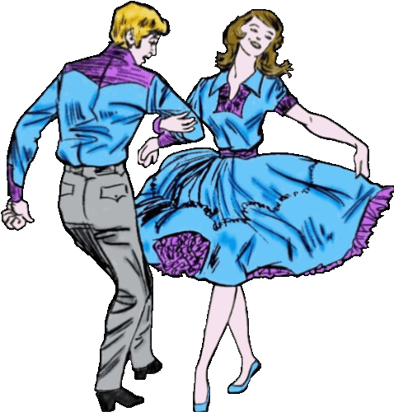

MAY 23, 2020 will hold a ROUND AND SQUARE DANCE,
$10.00 PER PERSON
5:00PM POTLUCK DINNER-7:00PM DANCING
At the ULSTER COUNTY FAIRGROUNDS-4-H BUILDING,
249 LIBERTYVILLE RD., NEW PALTZ, NY 12561
FEATURING BEN ROUNDS AND HIS BAND
FOR RESERVATIONS CALL: 294-9016 OR DMJURE33@FRONTIERNET.NET

